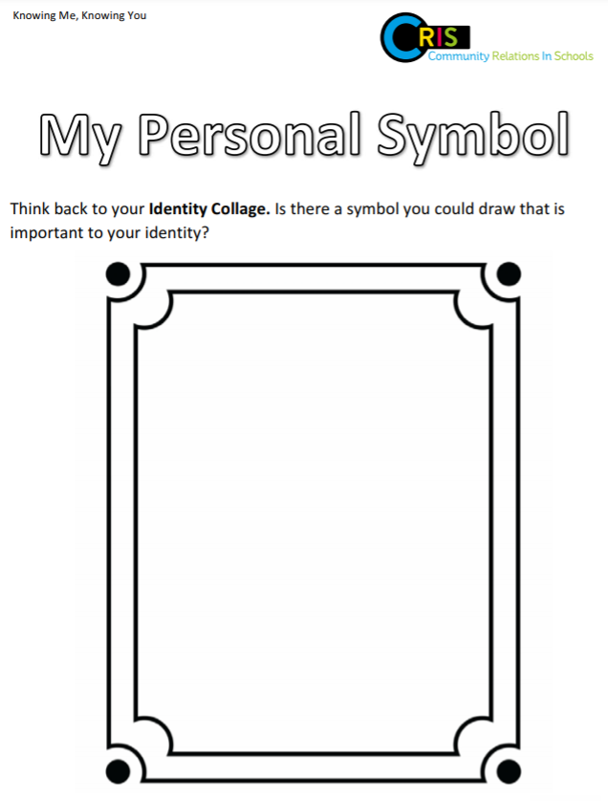
How does this symbol make you feel? ___________________________________________________
_______________________________________________________________________________________

Why is this symbol important to you? ___________________________________________________
_______________________________________________________________________________________

